What is a State Machine Diagram?
A State diagram is a UML diagram which is used to represent the condition of the system or part of the system at finite instances of time. It’s a behavioral diagram and it represents the behavior using finite state transitions.
- State Machine diagrams are also known as State Diagrams and State-Chart Diagrams. These both terms can be used interchangeably.
- A state machine diagram is used to model the dynamic behaviour of a class in response to time and changing external stimuli( events that cause the system to change its state from one to another).
- We can say that every class has a state but we don't model every class using State Machine diagrams.
Let's understand the State Machine Diagram with the help user verification example:

Example:



Step 1: Identify the System:
- Understand what your diagram is representing.
- Whether it's a machine, a process, or any object, know what different situations or conditions it might go through.

Step 2: Identify Initial and Final States:
- Figure out where your system starts (initial state) and where it ends (final state).
- These are like the beginning and the end points of your system's journey.

Step 3: Identify Possible States:
- Think about all the different situations your system can be in.
- These are like the various phases or conditions it experiences.
- Use boundary values to guide you in defining these states.

Step 4: Label Triggering Events:
- Understand what causes your system to move from one state to another.
- These causes or conditions are the events.
- Label each transition with what makes it happen.

Step 5: Draw the Diagram with appropriate notations:
- Now, take all this information and draw it out.
- Use rectangles for states, arrows for transitions, and circles or rounded rectangles for initial and final states.
- Be sure to connect everything in a way that makes sense.

Example: Online Order System
Let's understand State Machine diagram with the help of an example, ie for an Online Order :
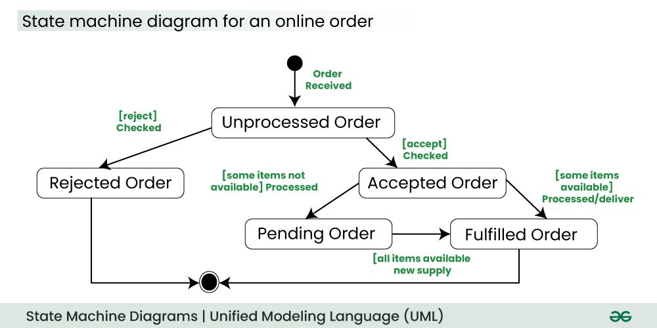

FOR LIBRARY

